Introduction to Challenge 1

During this course we want you to create a chat application. We call it *chatter|app*. It is similar to known chat applications in a sense that it allows users to post messages in different channels (e.g. #Octoberfest, on the left in the picture below).

Each message will be displayed with the corresponding user name and time the message was submitted. Furthermore there will be a difference in the appearance between own messages and messages from other people as you can see on the right in the picture below.

Having completed the *MakeYourOwnApp* course, you will have learned how to create an app looking similar to the one below.

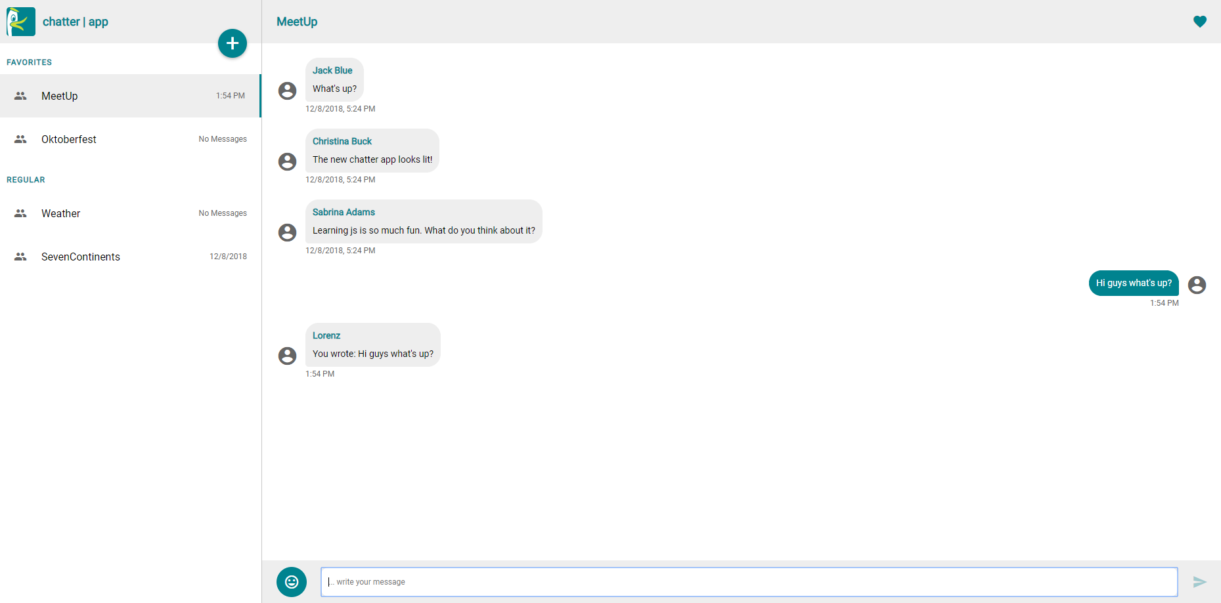

General information about the implementation challenges

Each challenge has the same structure that is briefly explained below.

* Every challenge starts with a **general overview** of the tasks and if they are mandatory or voluntary.
* Furthermore, a **picture** of how the chatter|app should look like when all tasks of the challenge are implemented is provided.
* Below the picture are the **criteria** by which your solution will be graded.
* The criteria are followed by **detailed instructions** on how to approach the programming tasks to develop the chatter|app. Each task can vary in length and difficulty. There will often be more than one solution to solve the tasks, especially later in the course.
* After the challenge description there is a **discussion board** to discuss your approach or ask questions, e.g. when you are stuck with a certain task.